N+ - Network security, Maintenance and Troubleshooting procedures

- Secure networks with firewalls NAT, port filtering, packet filtering, and other methodsPending

[Q-1] Set up Windows Defender Firewall on your Windows laptop or PC and create a new inbound rule to block all incoming traffic on port 8080. Take a screenshot of the rule you created.

[ANS]

- Steps:
- Press Windows + R, type wf.msc, and press Enter.
- Click Inbound Rules → New Rule.
- Select Port → Next.
- Choose TCP and enter 8080 in Specific Local Ports.
- Click Next.
- Select Block the Connection.
- Apply to Domain, Private, Public.
- Name the rule: Block Port 8080
- Click Finish.

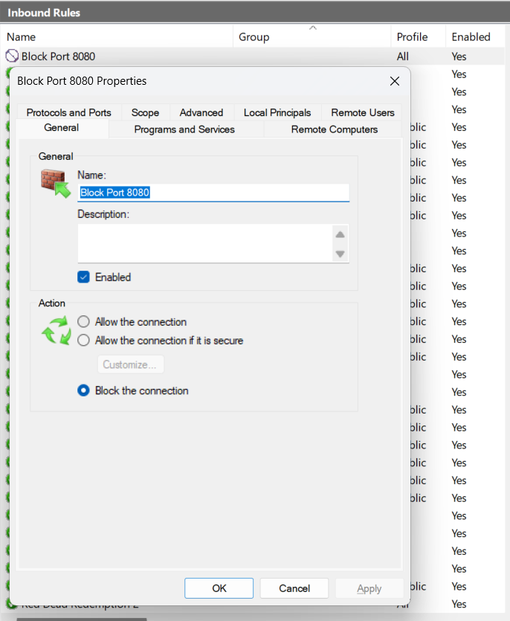

[Q-2] Simulate NAT (Network Address Translation) by drawing a simple diagram showing how your home WiFi router assigns private IP addresses to your phone, laptop, and smart TV, and how it translates them to a single public IP for internet access. Hint: Use any drawing tool or even hand-draw and click a photo.

[ANS]

- NAT Diagram

INTERNET
Public IP: 49.36.120.10
|
|
+----------------+
| WiFi Router |
| NAT Enabled |
+----------------+
/ | \
/ | \
/ | \
/ | \
Laptop Phone Smart TV
192.168.1.2 192.168.1.3 192.168.1.4

- Explanation
- The router assigns private IP addresses to devices inside the home network.
- When devices access the internet, the router translates their private IPs into a single public IP using NAT.
- This saves public IP addresses and adds a layer of security.

[Q-3] Configure port filtering using your WiFi router's admin panel (or use a router simulator online if you don't have access). Block outgoing traffic on port 25 (SMTP) and explain in 2 sentences how this could help prevent spam from your network.

[ANS]

- Configuration Steps
- Login to Router Admin Panel.
- Example: http://192.168.1.1
- Navigate to:
- Security → Access Control
or
- Firewall → Port Filtering
- Create Rule:

Setting | Value
Direction | Outbound
Protocol | TCP
Port | 25
Action | Deny / Block

- Save and Apply.

[Q-4] Given a sample packet filtering rule set (provided by your trainer), identify which of these three sample packets would be allowed or blocked: 1) HTTP request from 192.168.1.5 to 172.217.166.78:80, 2) SSH request from 10.0.0.10 to 34.201.23.1:22, 3) DNS query from 192.168.1.7 to 8.8.8.8:53. Hint: Focus on source/destination IPs and ports in the rule set.

[ANS]

- Assumed Rule Set

Rule | Action
Allow HTTP (Port 80) | Allow
Allow DNS (Port 53) | Allow
Block SSH (Port 22) | Block

- Packet Evaluation

Packet | Result | Reason
HTTP request from 192.168.1.5 → 172.217.166.78:80 | Allowed | HTTP Port 80 is allowed
SSH request from 10.0.0.10 → 34.201.23.1:22 | Blocked | SSH Port 22 is blocked
DNS query from 192.168.1.7 → 8.8.8.8:53 | Allowed | DNS Port 53 is allowed

- Answer

- HTTP Request → Allowed
- SSH Request → Blocked
- DNS Query → Allowed

[Q-5] Research and list 3 ways Instagram or Zomato might use firewalls and packet filtering to protect their servers from attacks or misuse.

[ANS]

- Blocking Malicious Traffic
- Firewalls detect and block suspicious requests such as DDoS attacks, brute-force login attempts, and unauthorized access attempts before they reach the servers.

- Restricting Access to Internal Services
- Packet filtering ensures that only authorized systems can access databases, admin panels, and backend services, protecting sensitive user data.

- Filtering Application Requests
- Firewalls inspect incoming traffic and block harmful payloads such as SQL Injection, Cross-Site Scripting (XSS), and bot-generated traffic to keep services secure and available.

